- Energy policy of your organization

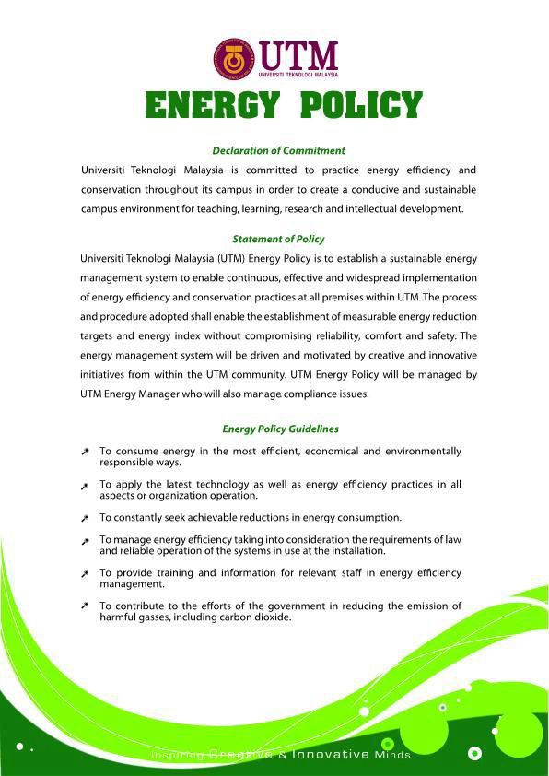
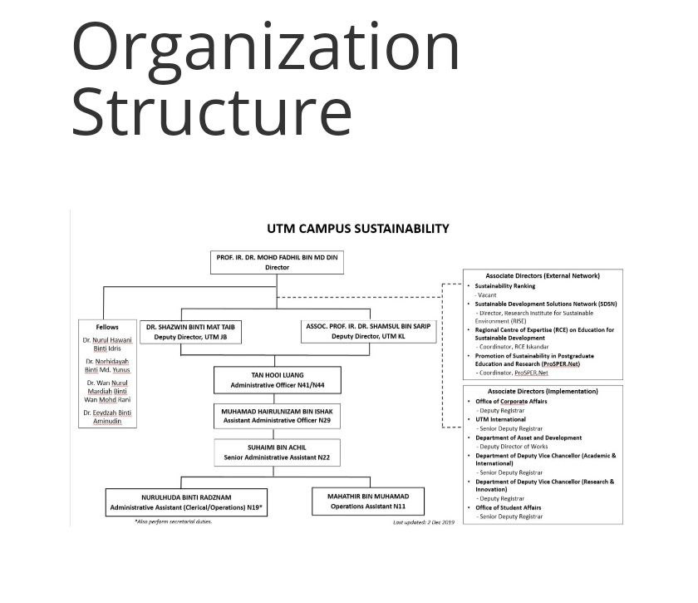

- Total energy saving and total cost saving after 1 year SEMS implemented (use 2021 energy consumption data as baseline

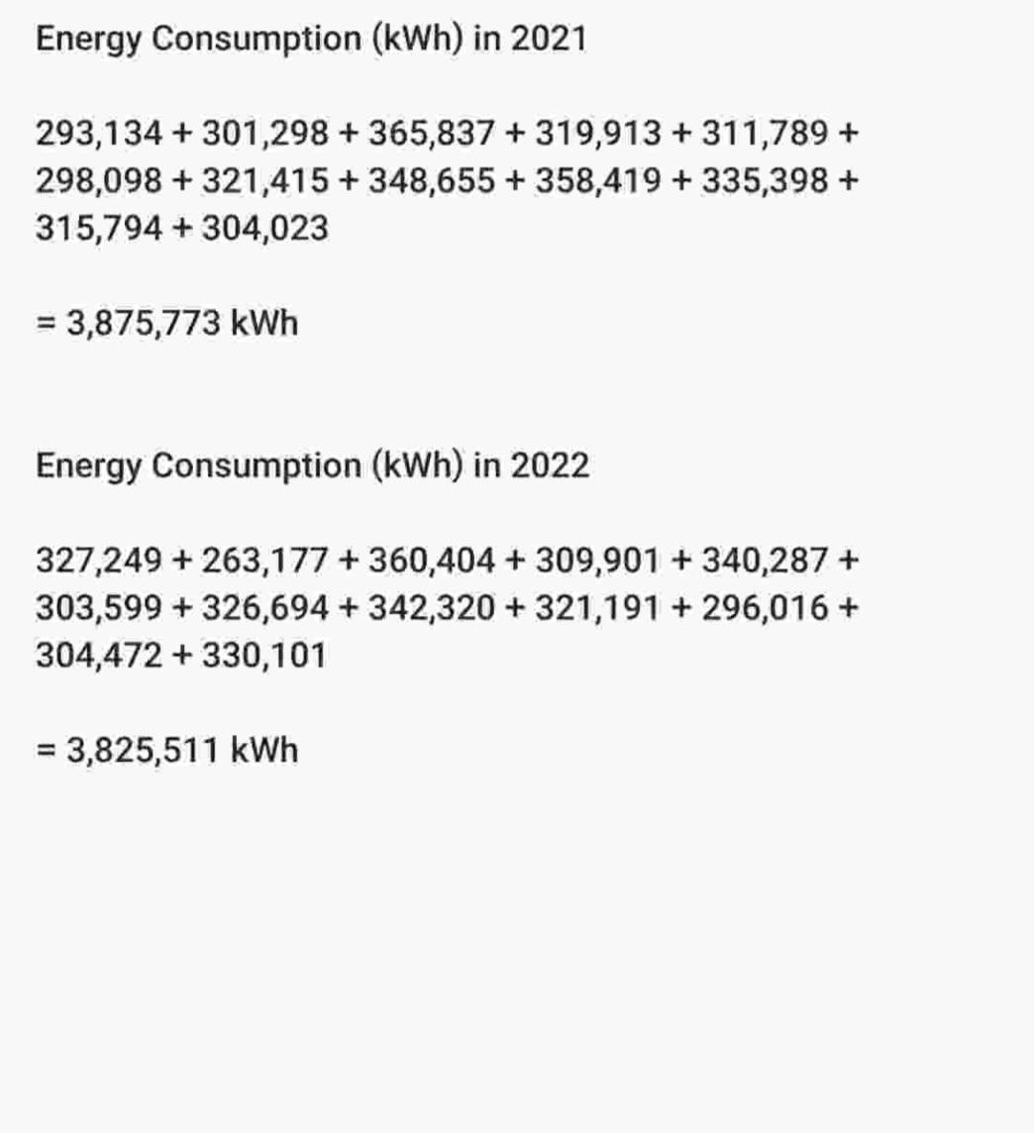

- Building Energy Index (Identify the star rating)

1.CEILING FAN.

Using your thermostat to set the temperature based on seasonality as well as whether you’re home or way, is a great wat to reduce your energy consumption and cut costs. Other ways to save include using ceiling fans, energy star appliances, energy efficient light bulbs and turning off home electronic when they aren’t in use. You can set up your shower, faucets, and toilets to use less water, and can change or empty your furnace filters to keep the unit at its most efficient. Sealing and insulating your house, closing doors and windows and using trees and other greenery to create built-in shading are other low-cost ways to ultimately save on energy usage and costs.

2. LED.

LED lights' increased energy efficiency is its primary benefit. This bulb helps lower your monthly electricity use because it uses very little electricity. Compared to light bulbs, it uses more energy because some of it is converted to heat, which will undoubtedly have an impact on the monthly power budget issued.

3. COOLING AND HEATING.

Reduce your reliance on heating and cooling systems. To decrease the area you need to cool or heat, shut the doors to any empty rooms. Close the drapes and outside window shades to use less energy in maintaining a constant inside temperature. Use an electric blanket, a wheat bag, a hot water bottle, or extra blanket on your bed instead of heating your room. Maintain your heating and cooling systems. So that it uses less energy to operate, clean your air conditioner or cooler. At night and when you're not home, turn off your heating and cooling.

